Data Science Salary Analysis

Sue Susman, MEd, BSN, RN

2023-07-05

**Table of Contents**

Project Overview: 1

Analysis 6

Conclusions 17

**Project Overview:**

The CEO of the small, but rapidly expanding company I work for is interested in adding a full-time data scientist to the staff. While the company is in the US, there is a possibility for this position to be remote for the right person. Factors to consider include rising salaries in the recession, along with a highly competitive job market. My research will explore salaries of data jobs in and out of the US. I will attempt to identify trends and patterns in the data science job market, including experience levels, location of companies, company sizes, salary differences between hiring someone in the US vs. someone outside of the US.

options(repos = "https://cran.rstudio.com/")

install.packages("tidyverse")  
## The downloaded binary packages are in  
## /var/folders/7w/vf_3wx5d6kq9bm2666hl7yy80000gn/T//RtmpJH2Hox/downloaded_packages

install.packages("ggwordcloud")  
## The downloaded binary packages are in  
## /var/folders/7w/vf_3wx5d6kq9bm2666hl7yy80000gn/T//RtmpJH2Hox/downloaded_packages

install.packages("viridis")  
## The downloaded binary packages are in  
## /var/folders/7w/vf_3wx5d6kq9bm2666hl7yy80000gn/T//RtmpJH2Hox/downloaded_packages

install.packages("scales")  
## The downloaded binary packages are in  
## /var/folders/7w/vf_3wx5d6kq9bm2666hl7yy80000gn/T//RtmpJH2Hox/downloaded_packages

install.packages("dplyr")  
## The downloaded binary packages are in  
## /var/folders/7w/vf_3wx5d6kq9bm2666hl7yy80000gn/T//RtmpJH2Hox/downloaded_packages

library(tidyverse)

## ── Attaching core tidyverse packages ──────────────────────── tidyverse 2.0.0 ──  
## ✔ dplyr 1.1.2 ✔ readr 2.1.4  
## ✔ forcats 1.0.0 ✔ stringr 1.5.0  
## ✔ ggplot2 3.4.2 ✔ tibble 3.2.1  
## ✔ lubridate 1.9.2 ✔ tidyr 1.3.0  
## ✔ purrr 1.0.1   
## ── Conflicts ────────────────────────────────────────── tidyverse_conflicts() ──  
## ✖ dplyr::filter() masks stats::filter()  
## ✖ dplyr::lag() masks stats::lag()  
## ℹ Use the conflicted package (<http://conflicted.r-lib.org/>) to force all conflicts to become errors

library(ggwordcloud)  
 library(viridis)

## Loading required package: viridisLite

library(scales)

## Attaching package: 'scales'

## The following object is masked from 'package:viridis':  
## viridis_pal

## The following object is masked from 'package:purrr':  
## discard

## The following object is masked from 'package:readr':  
## col_factor

library(dplyr)  
  
 options(repr.plot.width = 15, repr.plot.height = 15)

**Loading Datasets**

#Main Data set  
salary_df <- read.csv("data.csv")  
  
#Country codes Data set, used for cleaning later  
iso_df <- read.csv("wikipedia-iso-country-codes.csv")

**Inspecting The Data**

Checking the dimensions of a dataframe can be useful for understanding the size and structure of your data and for performing various operations and analyses based on the number of rows and columns present.

t(t(names(salary_df))) # In summary, the code transposes the column names of the data_df dataframe and returns them as a column matrix to display the column names in a user-friendly manner.

## [,1]   
## [1,] "X"   
## [2,] "work_year"   
## [3,] "experience_level"   
## [4,] "employment_type"   
## [5,] "job_title"   
## [6,] "salary"   
## [7,] "salary_currency"   
## [8,] "salary_in_usd"   
## [9,] "employee_residence"  
## [10,] "remote_ratio"   
## [11,] "company_location"   
## [12,] "company_size"

#Dimensions of the data frame  
data_dimensions <- dim(salary_df)  
num_rows <- data_dimensions[1]  
num_cols <- data_dimensions[2]  
  
text <- paste("There are", num_rows,"Rows", "and", num_cols, "Columns", "in this dataset")

print(text)

## [1] "There are 607 Rows and 12 Columns in this dataset"

head(salary_df) #Displays the first couple of rows of the data frame.

## X work_year experience_level employment_type job_title  
## 1 0 2020 MI FT Data Scientist  
## 2 1 2020 SE FT Machine Learning Scientist  
## 3 2 2020 SE FT Big Data Engineer  
## 4 3 2020 MI FT Product Data Analyst  
## 5 4 2020 SE FT Machine Learning Engineer  
## 6 5 2020 EN FT Data Analyst  
## salary salary_currency salary_in_usd employee_residence remote_ratio  
## 1 70000 EUR 79833 DE 0  
## 2 260000 USD 260000 JP 0  
## 3 85000 GBP 109024 GB 50  
## 4 20000 USD 20000 HN 0  
## 5 150000 USD 150000 US 50  
## 6 72000 USD 72000 US 100  
## company_location company_size  
## 1 DE L  
## 2 JP S  
## 3 GB M  
## 4 HN S  
## 5 US L  
## 6 US L

str(salary_df) #Display list of columns and data types

## 'data.frame': 607 obs. of 12 variables:  
## $ X : int 0 1 2 3 4 5 6 7 8 9 ...  
## $ work_year : int 2020 2020 2020 2020 2020 2020 2020 2020 2020 2020 ...  
## $ experience_level : chr "MI" "SE" "SE" "MI" ...  
## $ employment_type : chr "FT" "FT" "FT" "FT" ...  
## $ job_title : chr "Data Scientist" "Machine Learning Scientist" "Big Data Engineer" "Product Data Analyst" ...  
## $ salary : int 70000 260000 85000 20000 150000 72000 190000 11000000 135000 125000 ...  
## $ salary_currency : chr "EUR" "USD" "GBP" "USD" ...  
## $ salary_in_usd : int 79833 260000 109024 20000 150000 72000 190000 35735 135000 125000 ...  
## $ employee_residence: chr "DE" "JP" "GB" "HN" ...  
## $ remote_ratio : int 0 0 50 0 50 100 100 50 100 50 ...  
## $ company_location : chr "DE" "JP" "GB" "HN" ...  
## $ company_size : chr "L" "S" "M" "S" ...

summary(salary_df) #Statistical summary of data

## X work_year experience_level employment_type   
## Min. : 0.0 Min. :2020 Length:607 Length:607   
## 1st Qu.:151.5 1st Qu.:2021 Class :character Class :character   
## Median :303.0 Median :2022 Mode :character Mode :character   
## Mean :303.0 Mean :2021   
## 3rd Qu.:454.5 3rd Qu.:2022   
## Max. :606.0 Max. :2022   
## job_title salary salary_currency salary_in_usd   
## Length:607 Min. : 4000 Length:607 Min. : 2859   
## Class :character 1st Qu.: 70000 Class :character 1st Qu.: 62726   
## Mode :character Median : 115000 Mode :character Median :101570   
## Mean : 324000 Mean :112298   
## 3rd Qu.: 165000 3rd Qu.:150000   
## Max. :30400000 Max. :600000   
## employee_residence remote_ratio company_location company_size   
## Length:607 Min. : 0.00 Length:607 Length:607   
## Class :character 1st Qu.: 50.00 Class :character Class :character   
## Mode :character Median :100.00 Mode :character Mode :character   
## Mean : 70.92   
## 3rd Qu.:100.00   
## Max. :100.00

# Checking for any NA values  
any(is.na(salary_df))

## [1] FALSE

#Checking for unique values per column  
library(dplyr)  
salary_df %>%   
 summarise(  
 work_year = n_distinct(work_year),  
 experience_level = n_distinct(experience_level),  
 employment_type = n_distinct(employment_type),  
 job_title = n_distinct(job_title),  
 salary = n_distinct(salary),  
 salary_currency = n_distinct(salary_currency),  
 salary_in_usd = n_distinct(salary_in_usd),  
 employee_residence = n_distinct(employee_residence),  
 remote_ratio = n_distinct(remote_ratio),  
 company_location = n_distinct(company_location),  
 company_size = n_distinct(company_size)  
 )

## work_year experience_level employment_type job_title salary salary_currency  
## 1 3 4 4 50 272 17  
## salary_in_usd employee_residence remote_ratio company_location company_size  
## 1 369 57 3 50 3

Cleaning the Data

There are a few problems we need to fix:

1. The experience_level, employment_type, employee_residence, company_size and company_location columns contain abbreviations that may not be easily understood, so I will rename the data contained in those columns to something more descriptive.

#Renamed abbreviations for the experience_level column  
salary_df$experience_level[salary_df$experience_level == "SE"] <- "Senior"  
salary_df$experience_level[salary_df$experience_level == "MI"] <- "Indermediate"  
salary_df$experience_level[salary_df$experience_level == "EN"] <- "Junior/Entry"  
salary_df$experience_level[salary_df$experience_level == "EX"] <- "Director/Executive"

#Renamed abbreviations for the employment_type column  
salary_df$employment_type[salary_df$employment_type == "FT"] <- "FullTime"  
salary_df$employment_type[salary_df$employment_type == "PT"] <- "PartTime"  
salary_df$employment_type[salary_df$employment_type == "CT"] <- "Contract"  
salary_df$employment_type[salary_df$employment_type == "FL"] <- "FreeLance"

#Renamed abbreviations for the company_size column  
salary_df$company_size[salary_df$company_size == "S"] <- "Small"  
salary_df$company_size[salary_df$company_size == "M"] <- "Medium"  
salary_df$company_size[salary_df$company_size == "L"] <- "Large"

#Pulling columns from salary_df and iso into vectors that we can iterate from.  
employee_residence <- salary_df %>% pull(employee_residence)  
Alpha.2.code <- iso_df %>% pull(Alpha.2.code)  
Country_name <- iso_df %>% pull(English.short.name.lower.case)  
index <- 0  
new_employee_residence <- c()  
  
#Looping through each item in new_employee_residence  
for (item in employee_residence) {  
  
#check where the item exists in Alpha.2.code, then assign the index found in Alpha.2.code to index  
index <- which(Alpha.2.code == item)[1]  
  
#use the index to find the corresponding Country_name, then append that Country_name to new_employee_residence, save to new_employee_residence  
new_employee_residence <- append(new_employee_residence, Country_name[index])}  
  
# assign new_employee_residence to the employee_residence column  
salary_df$employee_residence <- new_employee_residence

str(salary_df$experience_level)

## chr [1:607] "Indermediate" "Senior" "Senior" "Indermediate" "Senior" ...

str(salary_df$employment_type)

## chr [1:607] "FullTime" "FullTime" "FullTime" "FullTime" "FullTime" ...

str(salary_df$employee_residence)

## chr [1:607] "Germany" "Japan" "United Kingdom" "Honduras" ...

str(salary_df$company_size)

## chr [1:607] "Large" "Small" "Medium" "Small" "Large" "Large" "Small" ...

str(salary_df$company_location)

## chr [1:607] "DE" "JP" "GB" "HN" "US" "US" "US" "HU" "US" "NZ" "FR" "IN" ...

1. We do not need the “X”, “salary” or “salary_currency” columns for our analysis.

salary_df <- salary_df %>%  
select(-c(X, salary, salary_currency))  
str(salary_df)

## 'data.frame': 607 obs. of 9 variables:  
## $ work_year: int 2020 2020 2020 2020 2020 2020 2020 2020 2020 2020 ...  
## $ experience_level : chr "Indermediate" "Senior" "Senior" "Indermediate" ...  
## $ employment_type: chr "FullTime" "FullTime" "FullTime" "FullTime" ...  
## $ job_title: chr "Data Scientist" "Machine Learning Scientist" "Big Data Engineer" "Product Data Analyst" ...  
## $ salary_in_usd: int 79833 260000 109024 20000 150000 72000 190000 35735 135000 125000 ...  
## $ employee_residence: chr "Germany" "Japan" "United Kingdom" "Honduras" ...  
## $ remote_ratio: int 0 0 50 0 50 100 100 50 100 50 ...  
## $ company_location: chr "DE" "JP" "GB" "HN" ...  
## $ company_size: chr "Large" "Small" "Medium" "Small" ...

1. Since remote_ratio contains ratios they all should have % at the end.

salary_df$remote_ratio <- gsub("%", "", salary_df$remote_ratio)

#Add a % at the end of every element in remote_ratio  
remote_ratio <- salary_df %>% pull(remote_ratio)  
new_remote_ratio <- paste0(remote_ratio, "%")  
salary_df$remote_ratio <- new_remote_ratio

str(salary_df$remote_ratio)

## chr [1:607] "0%" "0%" "50%" "0%" "50%" "100%" "100%" "50%" "100%" "50%" ...

# Analysis

library(ggplot2)  
library(dplyr)

experience_level <- data.frame(experience_level = salary_df$experience_level)  
experience_counts <- experience_level %>% count(experience_level)

ggplot(data = experience_level) +  
 geom_bar(mapping = aes(x = experience_level, fill = experience_level)) +  
 geom_text(data = experience_counts, aes(x = experience_level, y = n, label = n), vjust = -0.5) +  
 theme(axis.text.x = element_text(angle = 45, hjust = 1), text = element_text(size = 12)) +  
 labs(title = "Distribution of Experience Level",  
 x = "Experience Level",  
 y = "Count",  
 fill = "Experience Level") +  
 coord_cartesian(ylim = c(0, 300))

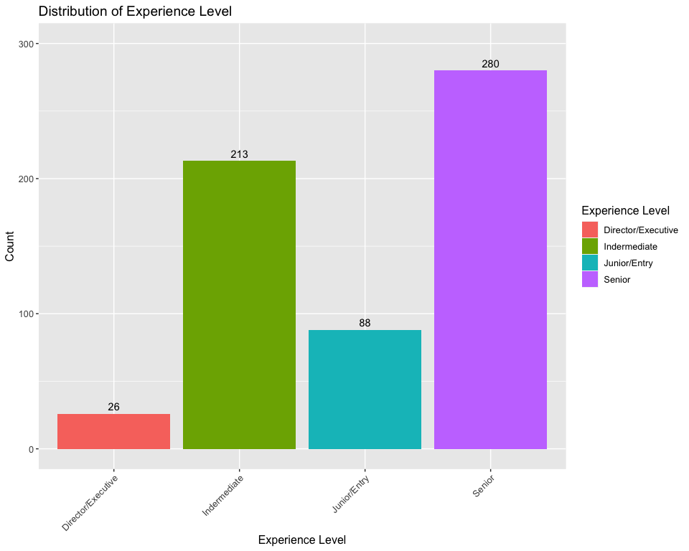

The data in this dataset suggests that most employees in the data science field are either at the Intermediate or Senior levels.

library(ggplot2)  
  
query <- salary_df %>%  
 select(job_title, experience_level) %>%  
 group_by(job_title, experience_level) %>%  
 summarise(Count = n()) %>%  
 arrange(desc(Count)) %>%  
 filter(job_title %in% c("Data Engineer", "Data Scientist", "Data Analyst", "Machine Learning Engineer", "Analytics Engineer", "Data Architect", "Research Scientist", "Applied Scientist", "Data Science Manager", "Research Engineer"))

## `summarise()` has grouped output by 'job_title'. You can override using the  
## `.groups` argument.

ggplot(query, aes(x = job_title, y = Count, fill = experience_level)) +  
 geom_bar(stat = "identity", position = "dodge") +  
 geom_text(aes(label = Count, group = experience_level), position = position_dodge(width = 0.9), vjust = -0.5, size = 2, color = "black") +  
 theme(axis.text.x = element_text(angle = 50, hjust = 1), text = element_text(size = 12)) +  
 labs(title = "Experience Level / Job Title", subtitle = "For the 10 most popular data science jobs", x = "Job Title")

The ratio of Seniors vs other experience levels is roughly the same per job title.

library(ggplot2)  
  
employment_type <- data.frame(employment_type = salary_df$employment_type)  
  
ggplot(data = employment_type, aes(x = employment_type)) +  
 geom_bar(fill = "orange") +  
 geom_text(stat = "count", aes(label = after_stat(count)), vjust = -0.5, color = "black") +  
 labs(title = "Employment Type Distribution", x = "Employment Type", y = "Count") +  
 theme(axis.text.x = element_text(angle = 45, hjust = 1), text = element_text(size = 14)) +   
 scale_y_continuous(limits = c(0, 700))

The data in this dataset suggests that most employees in the data science field are employed full time.

job_title_counts <- table(salary_df$job_title)  
  
# Order the job titles in decreasing order  
ordered_counts <- sort(job_title_counts, decreasing = TRUE)  
  
# Display the ordered job title counts  
ordered_counts

##   
## Data Scientist   
## 143   
## Data Engineer   
## 132   
## Data Analyst   
## 97   
## Machine Learning Engineer   
## 41   
## Research Scientist   
## 16   
## Data Science Manager   
## 12   
## Data Architect   
## 11   
## Big Data Engineer   
## 8   
## Machine Learning Scientist   
## 8   
## AI Scientist   
## 7   
## Data Analytics Manager   
## 7   
## Data Science Consultant   
## 7   
## Director of Data Science   
## 7   
## Principal Data Scientist   
## 7   
## BI Data Analyst   
## 6   
## Computer Vision Engineer   
## 6   
## Lead Data Engineer   
## 6   
## ML Engineer   
## 6   
## Applied Data Scientist   
## 5   
## Business Data Analyst   
## 5   
## Data Engineering Manager   
## 5   
## Head of Data   
## 5   
## Analytics Engineer   
## 4   
## Applied Machine Learning Scientist   
## 4   
## Data Analytics Engineer   
## 4   
## Head of Data Science   
## 4   
## Computer Vision Software Engineer   
## 3   
## Data Science Engineer   
## 3   
## Lead Data Analyst   
## 3   
## Lead Data Scientist   
## 3   
## Machine Learning Developer   
## 3   
## Machine Learning Infrastructure Engineer   
## 3   
## Principal Data Engineer   
## 3   
## Cloud Data Engineer   
## 2   
## Director of Data Engineering   
## 2   
## ETL Developer   
## 2   
## Financial Data Analyst   
## 2   
## Principal Data Analyst   
## 2   
## Product Data Analyst   
## 2   
## 3D Computer Vision Researcher   
## 1   
## Big Data Architect   
## 1   
## Data Analytics Lead   
## 1   
## Data Specialist   
## 1   
## Finance Data Analyst   
## 1   
## Head of Machine Learning   
## 1   
## Lead Machine Learning Engineer   
## 1   
## Machine Learning Manager   
## 1   
## Marketing Data Analyst   
## 1   
## NLP Engineer   
## 1   
## Staff Data Scientist   
## 1

library(wordcloud)

## Loading required package: RColorBrewer

library(RColorBrewer)  
  
# Convert job_title to character  
salary_df$job_title <- as.character(salary_df$job_title)  
  
# Filter the data based on job titles with count > 5  
filtered_counts <- job_title_counts[job_title_counts > 5]  
  
# Generate 20 bright colors by repeating the "Set1" palette  
num_colors <- 20  
colors <- rep(brewer.pal(9, "Set1"), length.out = num_colors)  
  
# Create a data frame with word frequencies  
word_data <- data.frame(word = names(filtered_counts),  
 freq = as.numeric(filtered_counts))  
  
# Set a dark background for the word cloud  
par(bg = "black")  
  
# Generate the word cloud using wordcloud  
set.seed(123) # For reproducibility of colors and angles  
wordcloud(word_data$word, word_data$freq, scale = c(2.5, 1), random.order = TRUE,  
 colors = colors, rot.per = 0.2, random.color = TRUE)

library(ggplot2)  
library(dplyr)  
  
# Create a data frame with salary counts  
salary <- salary_df %>%  
 group_by(salary_in_usd) %>%  
 summarise(count = n())  
  
# Convert salary_in_usd to numeric  
salary$salary_in_usd <- as.numeric(as.character(salary$salary_in_usd))  
  
# Sort the data frame by salary_in_usd  
salary <- salary[order(salary$salary_in_usd), ]  
  
# Set plot dimensions  
options(repr.plot.width = 15, repr.plot.height = 15)  
  
# Create the histogram plot with binwidth of 100000  
ggplot(salary, aes(x = salary_in_usd)) +  
 geom_histogram(binwidth = 100000, fill = "lightblue", color = "black") +  
 scale_x_continuous(labels = scales::comma) +  
 theme(text = element_text(size = 20)) +  
 labs(title = "Distribution of Salary", x = "Salary", y = "Count")

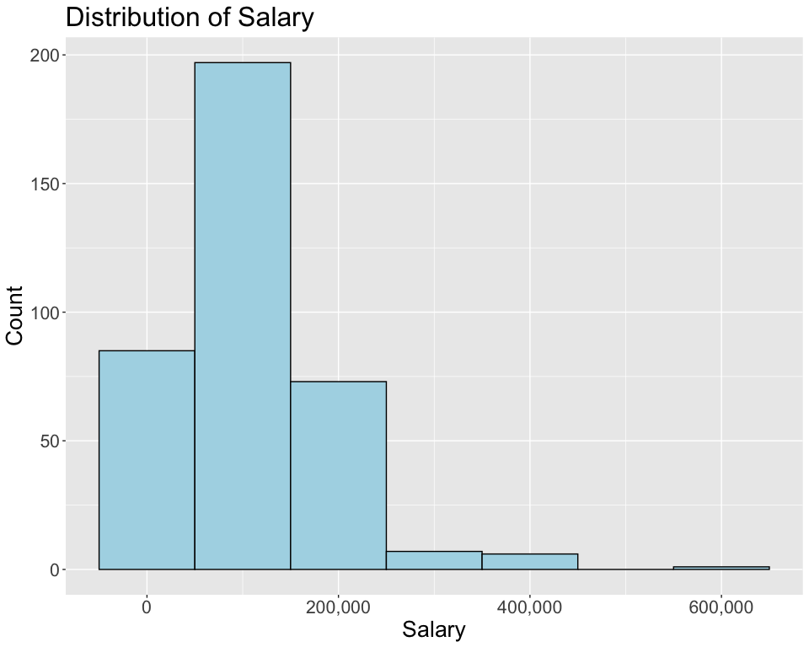

# Print summary statistics  
print(summary(salary))

## salary_in_usd count   
## Min. : 2859 Min. : 1.000   
## 1st Qu.: 53192 1st Qu.: 1.000   
## Median : 93000 Median : 1.000   
## Mean :107471 Mean : 1.645   
## 3rd Qu.:145000 3rd Qu.: 2.000   
## Max. :600000 Max. :15.000

library(ggplot2)  
library(scales)  
  
salary_df$salary_in_usd <- as.numeric(salary_df$salary_in_usd)  
  
temp <- data.frame(table(salary_df$job_title))  
  
temp <- temp %>%  
 arrange(desc(Freq)) %>%  
 head(n = 70)  
  
data <- salary_df %>%  
 select(job_title, salary_in_usd) %>%  
 filter(job_title == "Data Engineer" | job_title == "Data Scientist" | job_title == "Data Analyst" | job_title == "Machine Learning Engineer" | job_title == "Analytics Engineer" | job_title == "Data Architect" | job_title == "Research Scientist" | job_title == "Applied Scientist" | job_title == "Data Science Manager" | job_title == "Research Engineer" | job_title == "ML Engineer" | job_title == "Data Manager" | job_title == "Machine Learning Scientist" | job_title == "Data Science Consultant" | job_title == "Data Analytics Manager" | job_title == "Computer Vision Engineer" | job_title == "AI Scientist" | job_title == "BI Data Analyst" | job_title == "Business Data Analyst" | job_title == "Data Specialist" | job_title == "BI Developer" | job_title == "Applied Machine Learning Scientist" | job_title == "AI Developer" | job_title == "Big Data Engineer" | job_title == "Director of Data Science" | job_title == "Machine Learning Infrastructure Engineer" | job_title == "Applied Data Scientist" | job_title == "Data Operations Engineer" | job_title == "ETL Developer" | job_title == "Head of Data")  
  
options(repr.plot.width = 15, repr.plot.height = 15)  
  
data %>%  
 ggplot(aes(job_title, salary_in_usd, fill = job_title))+  
 geom_boxplot()+  
 theme_bw()+  
 theme(axis.text.x = element_text(angle = 90), legend.position = "none", text = element_text(size = 10))+  
 scale_y_continuous(labels = comma)+  
 labs(title = "Salary Ranges for Data Science Jobs", subtitle = "30 most popular data science jobs", x = "Job Titles", y = "Salary (USD)")

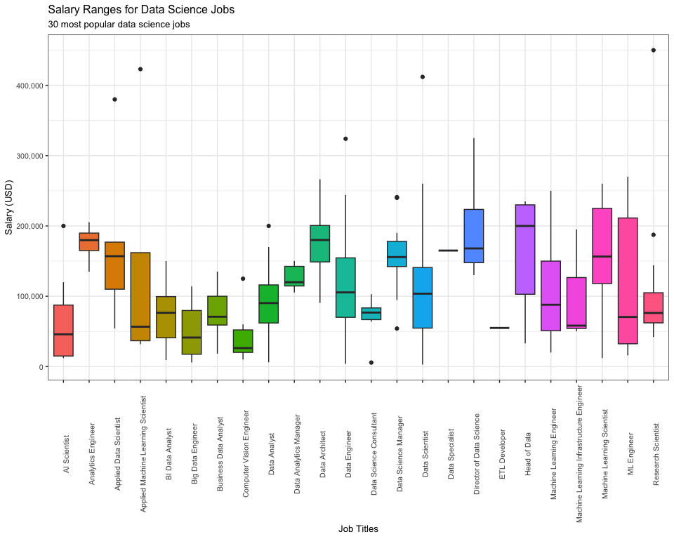

library(ggplot2)  
library(magrittr)

##   
## Attaching package: 'magrittr'

## The following object is masked from 'package:purrr':  
##   
## set_names

## The following object is masked from 'package:tidyr':  
##   
## extract

remote_ratio <- data.frame(table(salary_df$remote_ratio))  
  
options(repr.plot.width = 15, repr.plot.height = 15)  
  
remote_ratio %>%  
 ggplot() +  
 aes(x = Var1, y = Freq) +  
 geom_col(fill = "lightgreen", color = "black") +  
 geom_text(aes(label = Freq), vjust = -0.5, size = 5) +  
 xlab("Remote Ratio") +  
 ylab("Count") +  
 ylim(c(0, 500)) + # Set y-axis limits (adjust the upper limit as desired)  
 theme(text = element_text(size = 16)) +  
 labs(title = "Distribution of Remote Ratio") +  
 theme(plot.margin = margin(10, 10, 10, 10, "pt"))

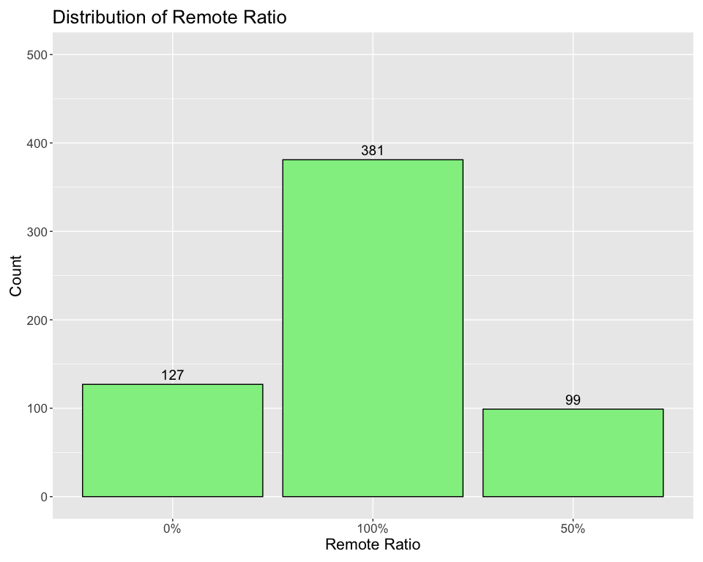

company_size <- data.frame(table(salary_df$company_size))  
  
options(repr.plot.width = 15, repr.plot.height = 15)  
  
 company_size %>%  
 ggplot() +  
 aes(x = Var1, y = Freq) +  
 geom_col(fill = "purple", color = "black") +  
 geom_text(aes(label = Freq), vjust = -0.5, size = 5) +  
 labs(title = "Company Size Distribution", x = "Company Size", y = "Count") +  
 ylim(c(0, 450)) + # Set y-axis limits (adjust the upper limit as desired)  
 theme(text = element_text(size = 16)) +  
 theme(plot.margin = margin(10, 10, 10, 10, "pt"))

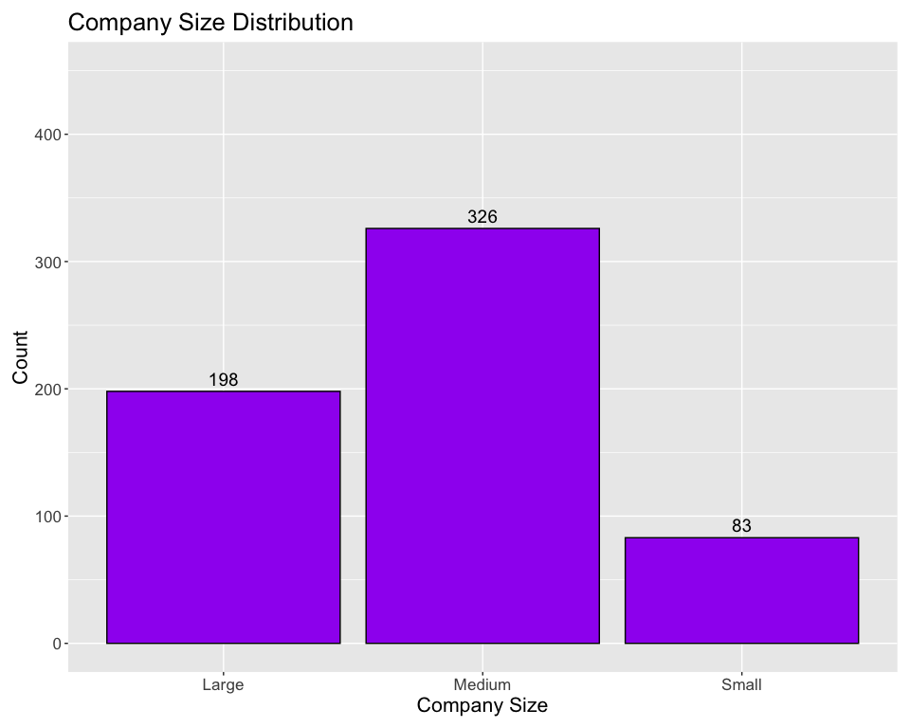

**Conclusions**

In this analysis, I explored the salaries of data science jobs in the US. I identified some trends and patterns in the data science job market, such as most employee’s experience being senior-level and most data science companies are in the US with company sizes ranging from 50-250 employees. In conclusion, my analysis provides a valuable snapshot of the current state and trends of data science salaries in the US, which can help data scientists and employers make informed decisions and plan their careers.